For Immediate Release
Contact - Walter Maciel, walter@waltermacielgallery.com, 310-839-1840

Cross Fade, Curated by Brenda G. Williams
12 July – 16 August 2014
Opening Reception: Saturday, July 12th, 6-8pm

Walter Maciel Gallery is pleased to present Cross Fade, an exhibition curated by Brenda G. Williams that features six distinct perspectives examining how we view female identity and sexuality in contemporary culture. The show includes the work of Lili Bernard, Tameka Norris, Lezley Saar, Christine Wang, Dana Weiser and Kim Ye.

Cross fade is defined as a cinematic technique that allows for one scene to gradually fade away while the next scene subtly appears. Similarly, the group of work presented in Cross Fade unfolds as a cohesive conversation between a series of installations, sculptures, paintings and video revealing different cultural contexts and identity of African American and Asian American women. The physicality of the work is often presented in a variety of formats including text to create a specific message, drag to convey a certain type of character, collage to connect the past and memories and repurposed objects to display historical events. Furthermore, these visible frameworks, subjects and ideas project a feeling or mood beyond what is seen.

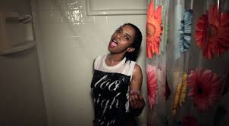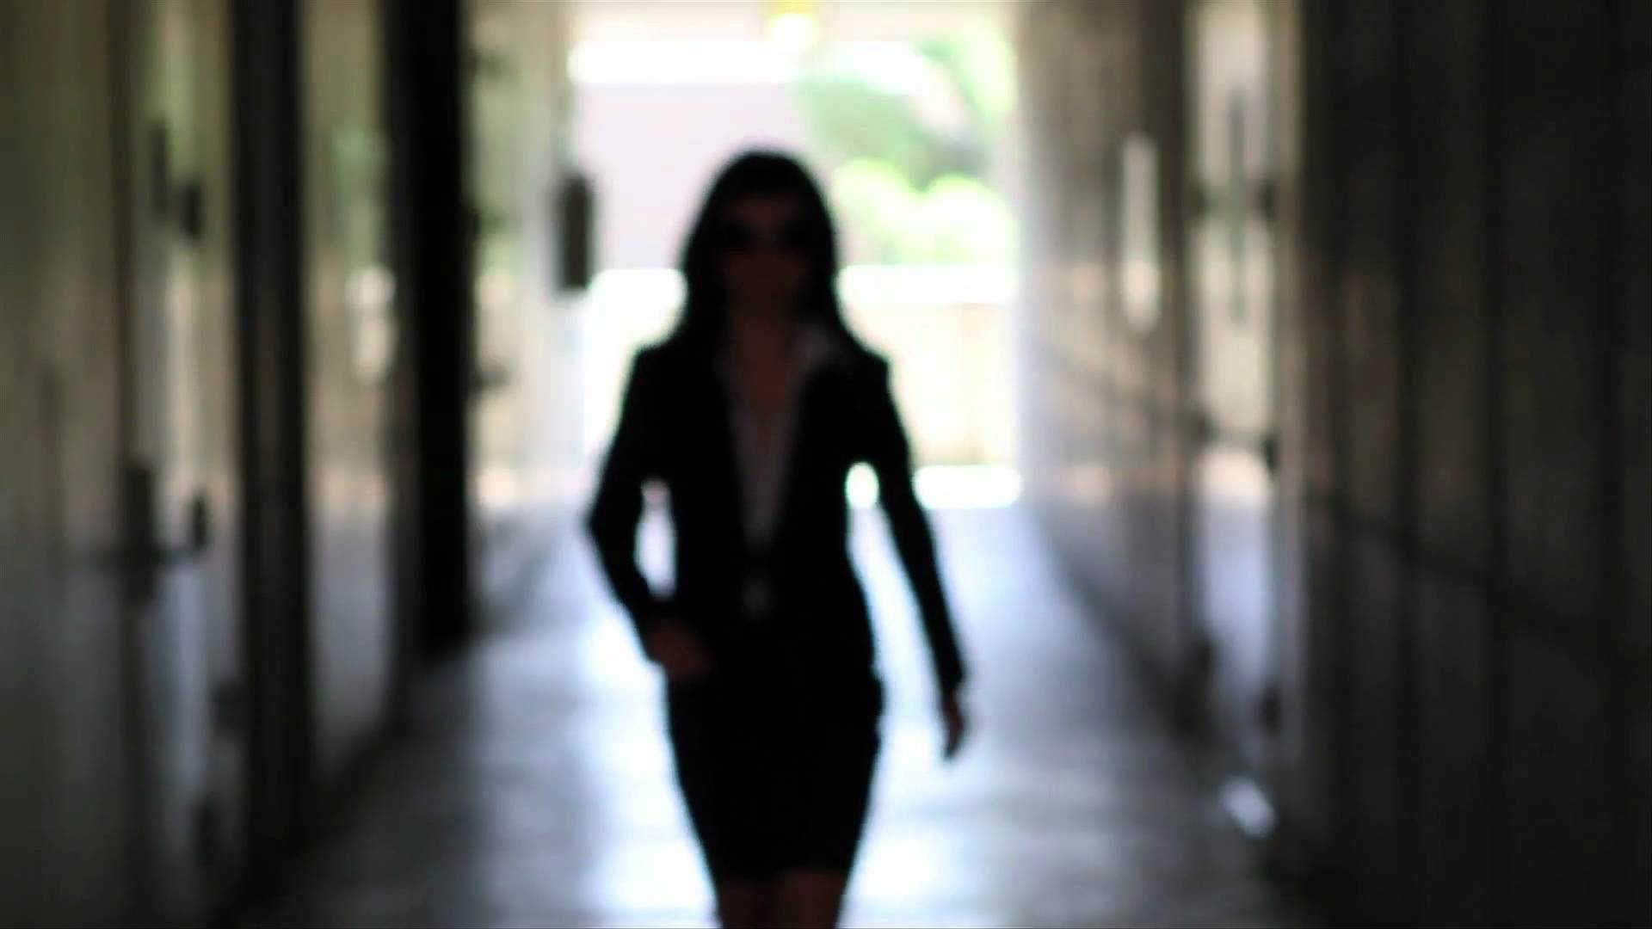
Within the context of the exhibition, the dialogue does not follow one particular thread or trajectory; but rather questions the surface and emergence from vastly different positions. Video works by Tameka Norris and Kim Ye include the use of costume and props to challenge the reaction of their characters and their specific identities as a way of taking control of the viewer. For example in the video Meka Jean: Too Good for You Norris explores her sexuality and personal desire to be in control of certain situations, but the viewer begins to question her control through the observation of her demeanor and character. In contrast, Ye’s search for identity includes objectifying those who are part of her race and gender as noted in her piece Ultimate Match. Differing from her videos in the past that simply documented performances, Ye creates a false dating service featuring Asian women as the subjects with images and information suggesting only white men are welcome to apply.

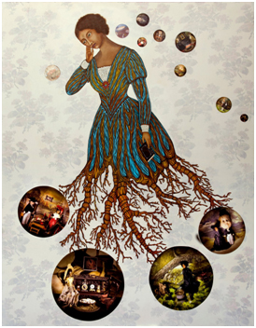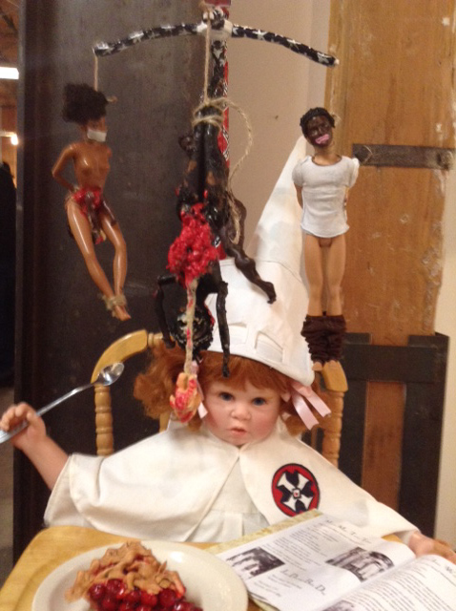
Punctuating these works, Lezley Saar and Lili Bernard instigate moments of allegiance and shared experience that reveal how birthright and family history collectively create vital moments of one’s political potential. Saar’s work explores her visions of identity, history, place and family as noted in the painting Therese Raquin depicting the bi-racial subject of the French novel by Emile Zola. The painting features a woman in Victorian dress whose lower body morphs into Saar’s clever interpretation of a family tree blossoming with visual memory bubbles that highlight moments in the novel. In comparison, Bernard explores her birthright and heritage by retelling explicit historical events relating to her culture; more precisely ”Black Female Identity as influenced by colonization”. In the sculpture American As Cherry Pie a doll clothed in traditional Ku Klux Klan garb sits in a highchair ready to devour a piece of cherry pie. Hanging from a patriotic armature, bloodied “ethnic” dolls represent the victims, Mary Turner and Laura Nelson who were lynched with their children in the early 20th century.
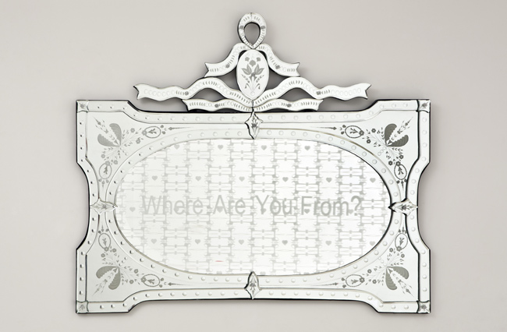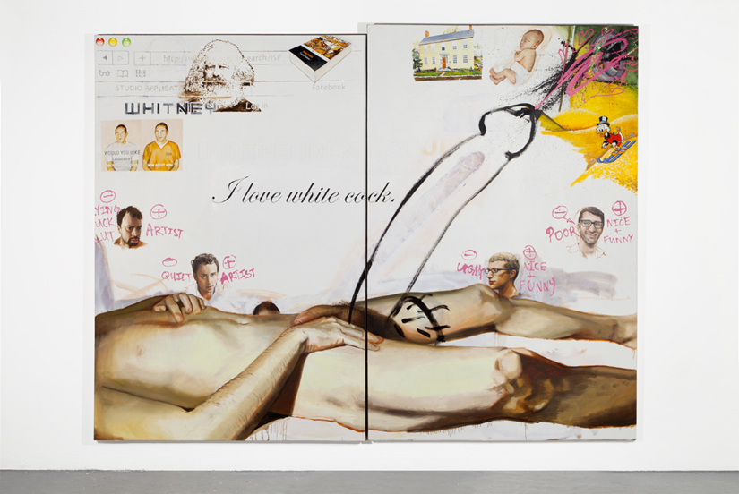
Projects by Dana Weiser and Christine Wang share the moments of confrontation and triumph over identity. Weiser etches selected words collected from derogatory phrases directed towards her into a mirror and has the viewer self reflect while reading the remarks. For example, the piece entitled Where Are You From? includes the question shown as text etched within a dainty floral inspired pattern revealing the awkward conversations of the artist’s past. Wang rages against stereotypes by playfully using words and imagery that comment on topics ranging from politics and religion to pop culture and consumerism thus challenging the viewer’s notion of bias. In her painting I Like White Cock an image of a nude male body lays across the foreground of the painting with a black line painting of a oversize penis extending from the groin. The content purposefully ignites controversy with a reverse play on racism while poking fun at inherent human behavior. Together, the projects presented in this exhibition surround the viewer with a diverse set of contexts and ideas within which the motifs of identity, experience and culture are continuously faded onto one another.
Brenda G. Williams is a local art consultant specializing in emerging contemporary artists. She attended Clark Atlanta University and majored in communications. Williams began her art career in Italy selling works on paper from a local gallery before returning to the states to manage the Eyes Gallery in Philadelphia. She moved to New York to work as a set designer on the movie Boomerang and began working for Yosi Barzilai at Sarajo where she sold tribal art and textiles, as well as Haitian art. Williams later moved to Los Angeles and immersed herself in the contemporary art world working on various independent projects. Her latest venture is a blog called ADDOBBO featuring images of contemporary artwork that she finds interesting and collectible. Williams organizes and leads an art group visiting galleries, museums and artists’ studios quarterly.

